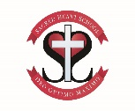
Curriculum Newsletter for Wharfe Class – Year 1/2 Children
Half Term 1 2024-25

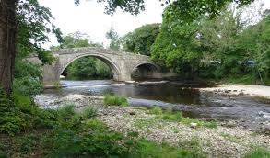
Hello all!
We hope you have all had a fantastic summer and your children have enjoyed their well deserved break. We are both very excited to be teaching your child and we look forward to the year ahead.
You can find below the curriculum areas that will be covered this half term. Of course, if you have any questions/concerns please do contact the school office to arrange an appointment to see us.
Many thanks and kind regards,
Miss Cheetham and Mrs Robinson
Maths – Year 1  Numbers  In class, we will be working on the children’s ability to recognise, represent and manipulate numbers to 10. The children will first develop their ability to sort and group objects using different criteria and will then move on to counting groups of objects up to 10 using a ten frame for assistance. The children will be introduced to vocabulary such as “digit”, “one more” and “one less” as well as the written names for each number. The children will also learn about ordinal numbers and will be introduced to number lines.  Part-whole within 10  The children will be introduced to part-whole models and will focus on different ways of partitioning numbers to 10. This will help them to write and compare number bonds.  Addition and subtraction within 10  This unit of work builds on the children’s knowledge of number bonds within 10, their use of number lines and their understanding that two parts make a whole.  The children will be introduced to “count on” and “count all” strategies and will develop an understanding of the idea that addition calculations can be performed in any order.  The children will look at subtraction as the inverse of addition and will count back, and work out a missing part.  The children will have access to a wide range of practical equipment to help them in their learning.  Year 2  Numbers to 100  In class, we will focus on the children’s ability to read and understand numbers to 100 using their understanding of place value to help them sort, compare and order numbers. The children will use different representations to show a number’s ‘10s’ and ‘1s’ which they will use to compare and order. Part-whole models and place value grids will be used to support their reasoning.  They will also begin to develop their ability to count forwards and backwards in steps of 2, 3, 5 and 10.  Addition and subtraction  The children will apply their place value understanding to addition and subtraction problems. Children will learn to use the inverse of one operation to check calculations using the other operation. They will also be introduced to the concept of “make 10” to aid mental calculations. |  | 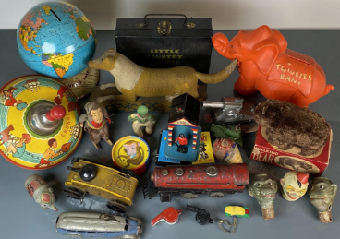  English  This half term we will be looking at books around our Topic theme “Childhood/School Days”. We will be retelling these stories, writing to characters in the book, describing characters, predicting what might happen next and changing parts of the story to make our own version. We will also be looking at non-fiction books whereby the children will organise/write information texts. Finally, the children will explore a range of poems and will rewrite their own versions.  The key focus for our writing in Year 1 this half term is using capital letters and full stops in the right place and re-reading work back to check it makes sense.  For the Year 2 children, we will be developing their writing skills by looking at their punctuation and grammar, for example, sentence types, coordinating conjunctions and writing in the past tense.  Phonics  Year 1  The children will briefly revise ‘Phase 4’ of our Bug Club Phonic sessions. In these sessions the children will  practise reading and spelling CVCC words ('bump', 'nest', 'belt,' 'milk', etc). Practise reading and spelling high frequency words. They will also be applying their phonic knowledge that they have learnt so far to read and write sentences. We will then begin ‘Phase 5’ teaching focusing on new ways to write the sounds the children have already learnt. For example, we will revise ‘ai’ as in ‘rain’ but also learn ‘ay’ like ‘play’ and ‘a-e’ as in ‘cake’.  Year 2  The children will spend this half term revising several units from ‘Phase 5’ of our Bug Club phonics sessions. This will remind the children of the many alternative spellings for sounds (as exampled above). The children will be applying their phonics knowledge in their reading and writing daily.
RE Our topic for this term is: Chosen People  The children will develop an understanding that they are chosen by God and will be looking at the story of Abraham found in the Book of Genesis, the story of Moses found in the Book of Exodus and the story of Daniel found in the Book of Daniel. While looking at these stories, we will discuss/explore the meanings of bravery, trust, promises and faith in God. We will also be dedicating time to look at ‘Other Faiths’. |  | PE – In PE this term we will be learning about:  The children will be doing PE led by Mr Gibson, focusing on football and gymnastics. The sessions may be inside our school hall or outside depending on the nature of the lesson and the weather. Our PE days this half term are on a Tuesday and a Wednesday and we ask that on those days the children come into school dressed in their PE kits.
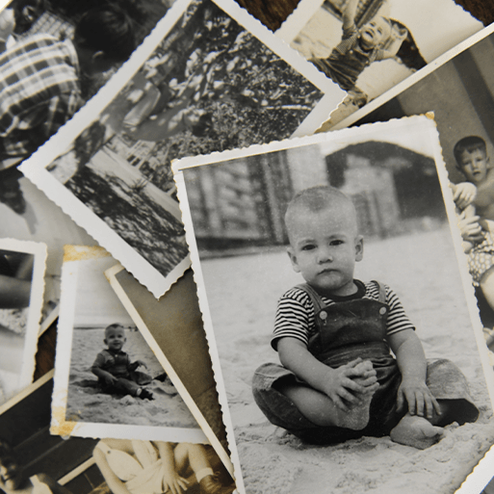
Curriculum- Our topic this half term is ‘Childhood/School Days’
History/Geography: We will be looking at everyday life and families today, the children will make comparisons with childhood from the 1950s. The children will explore artefacts and a range of different sources as they learn key vocabulary. The children will also identify the features of a 1950s map, comparing it to one from the present day. We will also be looking at the location of our school and will use Google Earth to explore the position of Sacred Heart.
Art and DT: We will begin our lessons by looking at colour wheels, using paint in the three primary colours. The children will then look at the concept of portrait and how the collage technique can be used.
Science: Biology- Animals
The children will understand that animals have offspring that grow into adults. They will look at the different structures and skin coverings of animals and will name and identify a range of common animals. We will be looking at carnivores, herbivores and omnivores and the basic needs that animals need to survive.

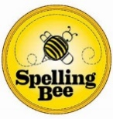  Homework and spellings  Year 1: If you would like to help your child at home, you could:  - Read the school reading book every day.  - Read a selection of other books and stories to your child or listen to an audio book together.  - Playing games such as snakes and ladders, bingo and other board games that involve number.  - Talk to the children about what day of the week/month of the year it is and what season we are in. Have a go at learning to spell the days of the week and months of the year.  Year 2: your child has been sent home with 20 spellings alongside a ‘Spelling Bee’ folder. The children, alongside those in KS2, will complete a low stake “spelling test” of those 20 spellings, at the start of the half term. Over the 8 weeks, we will spend time practising the spellings and putting them into sentences. In the last week of this half term, the children will complete another assessment (the same 20 spellings). Those children that improve by 5 or more/get 100% will receive a certificate. The class that improves the most will get the Spelling Bee Trophy! The children have been told to practise their spellings at home, wherever possible. | 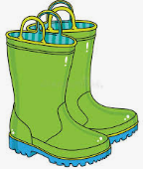  General information  Outdoor clothing  We are lucky enough to have our own outside area, which we will use throughout the year for a range of learning opportunities. Each child should have a warm outdoor coat and a pair of wellies that can be left in school. When the weather becomes colder, children should also have a hat, scarf and some warm gloves.  Rewards in the classroom –  As well as the use of “positive praise” as a form of rewarding children for their behaviour/work, we choose a daily ‘star of the day’. This child will get to be the front of the line, take the register and do other special jobs.  At the end of the week, one child will be chosen to take home “River Bear”. They are able take care of the class bear for the weekend, and are encouraged to write in River Bear’s notebook about what they have done over the weekend (children may also want to print off/ draw pictures in the notebook too).

